**U.A. High School_Solution_Documentation**

**Written by: Yuval Quina**

1. To begin with, I started the challenge with Nmap port scanning:

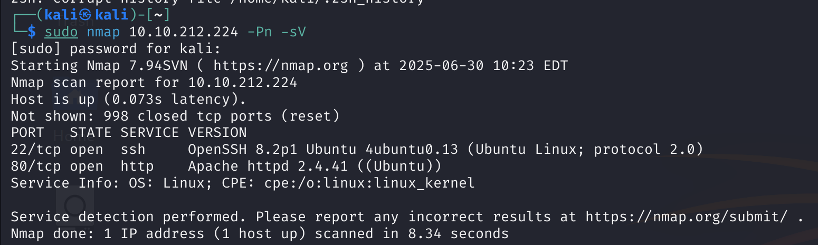

After completing the scanning, I opened the target’s website:

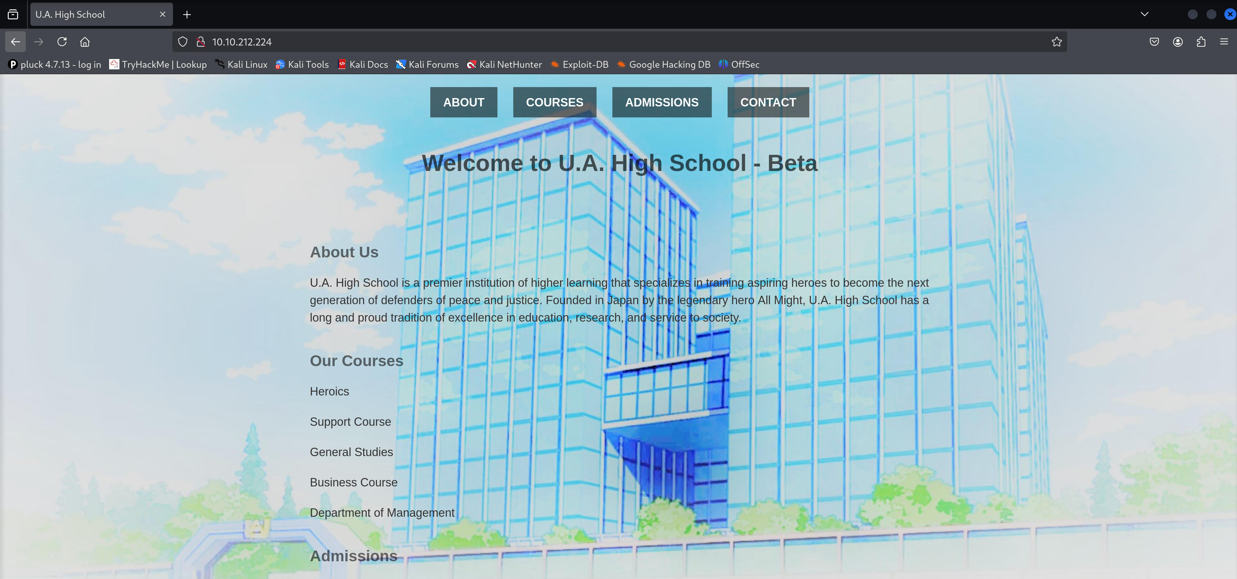

1. From that point, I did several things.

First of all, I performed a directories enumeration using “gobuster” tool:

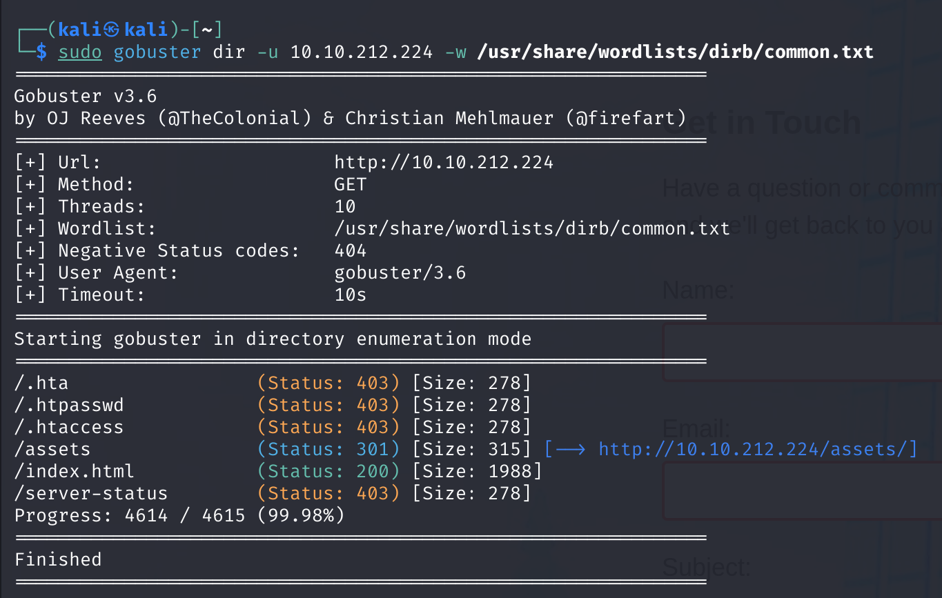

So, the 403 errors means that these are forbidden for me right now, the asset directory probably contains several things which I still don’t know, and the index page is the website start page.

Next, I navigated through the website pages and found the “contact” page which contains input text fields that look vulnerable:

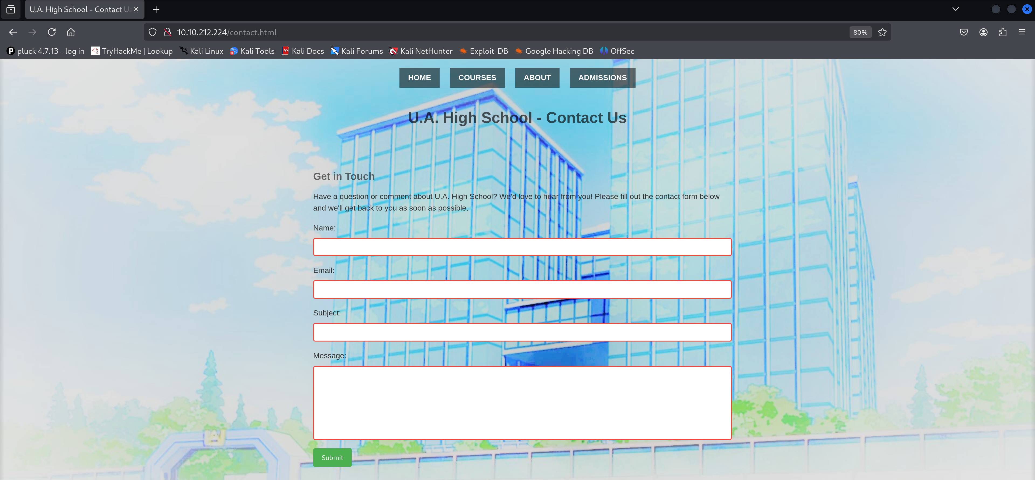

After entering some random values and clicking on the “Submit” button, I capture that contact packet using Burpsuite:

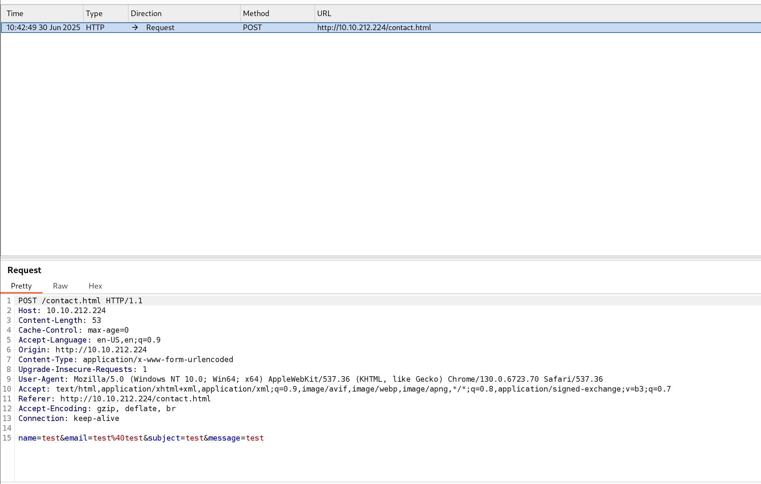

1. I found no vulnerable element, so I tried to enumerate directories in the “/assets/” directory:

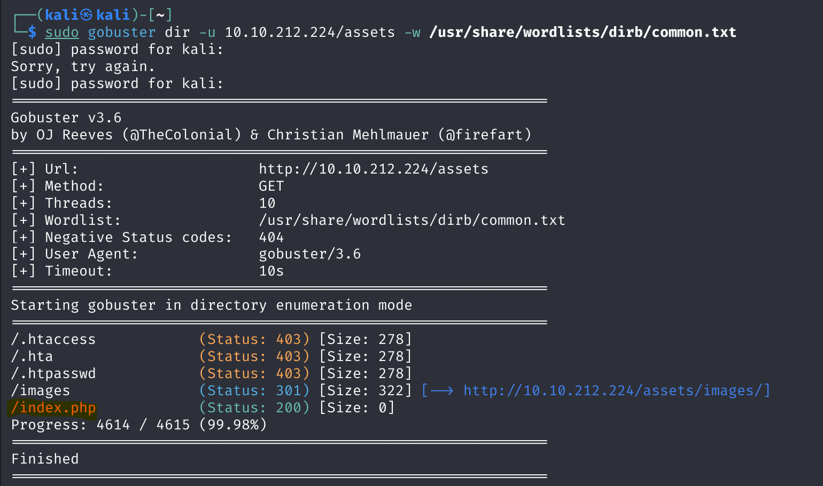

I found the “index.php” page in this directory and when I opened it I found an empty page:

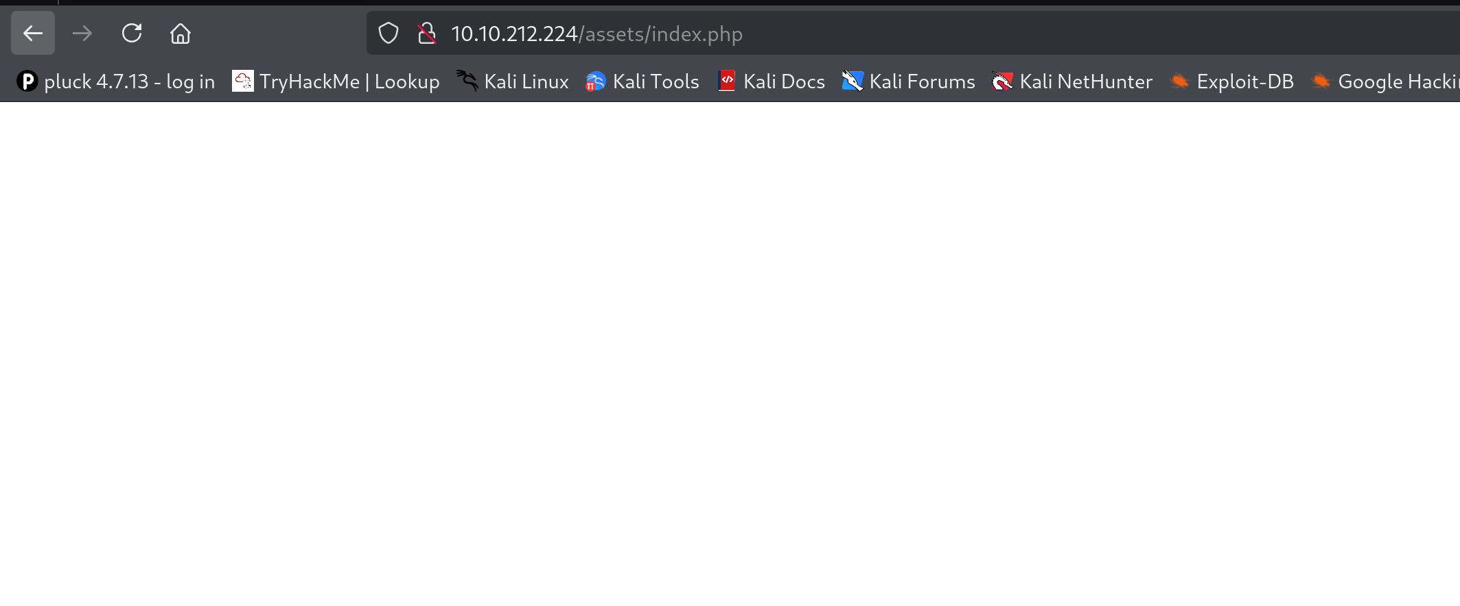

But then I remembered that an empty page can be a webshell of the target’s machine which probably runs a command like this which have the header ‘cmd’ which get input to a webshell



So, I checked the ‘id’ command using this flag over the url and it successfully gave me the results:

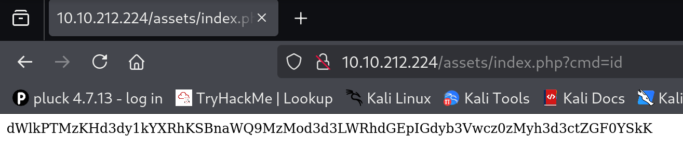

Now, I know that it doesn’t look like an appropriate output so I tried to decode it using base64 and it worked:

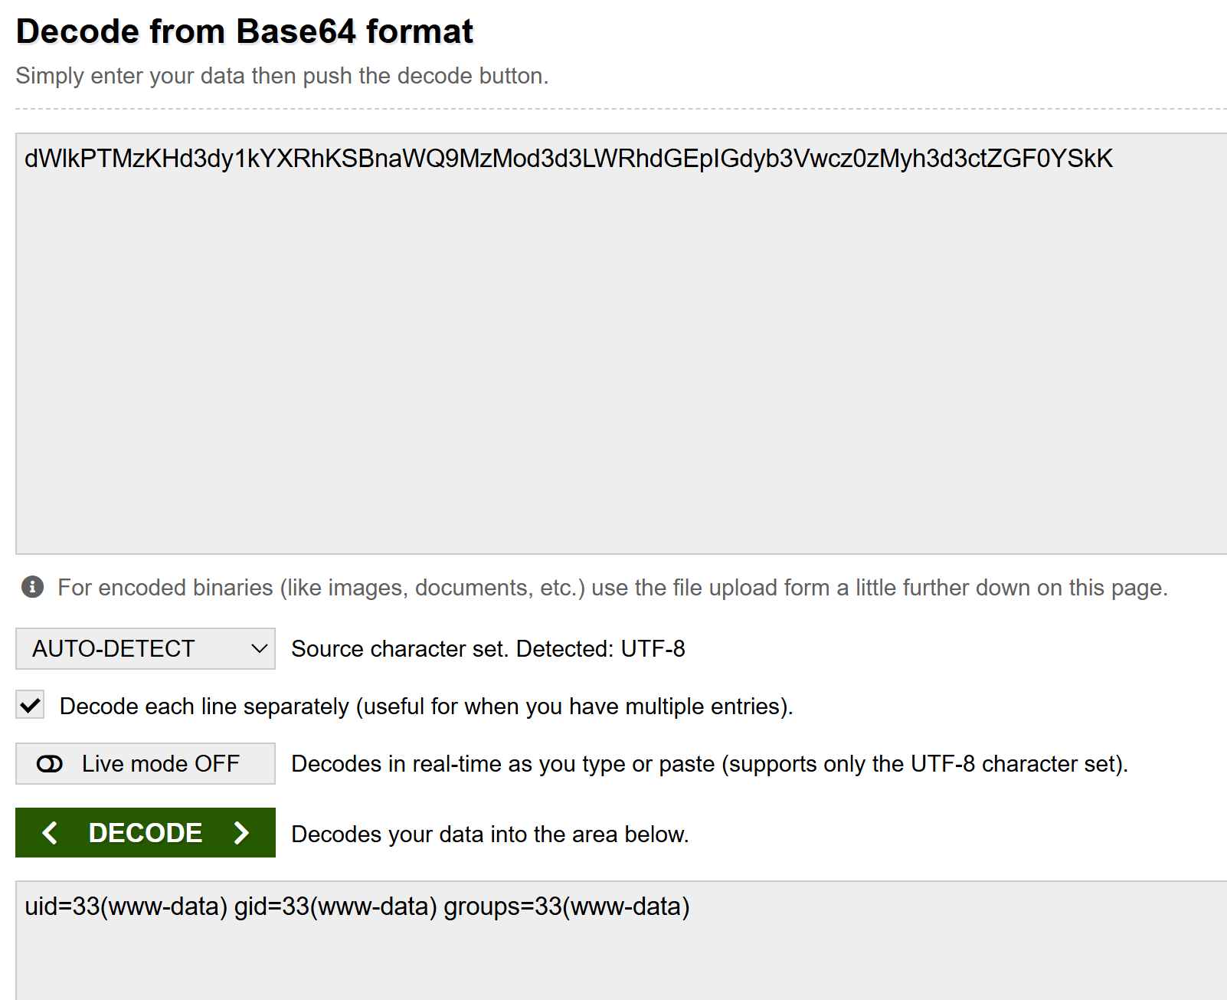

It was found to be encoded using ‘UTF-8’ cypher.

1. I found it very uncomfortable, so I used ‘netcat’ tool in order to gain a more comfortable shell over the target:

I executed this netcat listener:

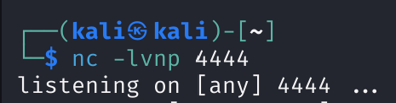

And this netcat reverse using <https://www.revshells.com/>:



I ran over the web page and got the reverse shell over the target machine in my machine:

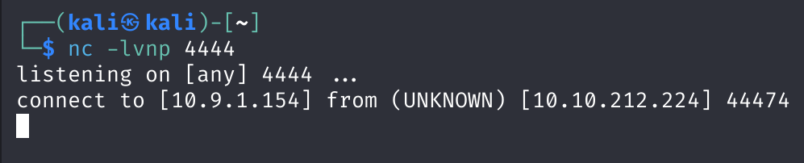

1. Now, I could navigate through the system and find the first flag file in this path: “/home/deku/user.txt”

When I tried to open it, I was faced with an error of “permission denied”:

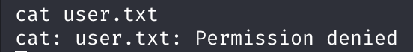

1. So, I try to find an vulnerability that will make me able to escalate my privilege by